Rest Api Token generation for postman

Header

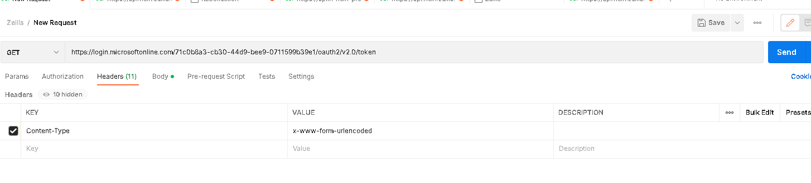

Body :

